**A**

**Project Based Learning Report**

**On**

**‘Automatic Attendance system using Face Recognition’**

## By

|  |  |  |
| --- | --- | --- |
| **Name of the Student** | **Roll. No.** | **Exam Seat No.** |
| Kakad Abhishek Satu | **23** | **S190101526** |
| Kale Abhishek Subhash | **24** | **S190101527** |
| Karle Rushikesh Shivshankar | **25** | **S190101528** |
| Kawade Ganesh Popat | **27** | **S190101530** |
| Mule Ashutosh Bhausaheb | **37** | **S190101541** |

**Under the guidance of Prof. Wakchaure Sir**



**Department of**

**SE(Automation & Robotics)**

**Amrutvahini College of Engineering, Sangamner-422608**

2022-2023

CERTIFICATE

Amrutvahini Sheti & ShikshanVikas Sanstha’s

**Amrutvahini College of Engineering, Sangamner**



## This is to certify that

|  |  |  |  |  |  |
| --- | --- | --- | --- | --- | --- |
| **Name of the Student** | **Roll. No.** | | | **Exam Seat No.** | |
| Kakad Abhishek Satu | | **23** | **S190101526** | |
| Kale Abhishek Subhash | | **24** | **S190101527** | |
| Karle Rushikesh Shivshankar | | **25** | **S190101528** | |
| Kawade Ganesh Popat | | **27** | **S190101530** | |
| Mule Ashutosh Bhausaheb | | **37** | **S190101541** | |

## **have completed a project on**

**“Automatic Attendance system using Face Recognition”**

## under the guidance of **Prof.Wakchaure Sir**

**as a part of**

## Project Based Learning during academic year 2022-2023

|  |  |  |
| --- | --- | --- |
| **Prof. Wakchaure Sir** |  | **Prof.** |
| **Mentor** | **Co- Mentor (If any)** | **Examiner** |

# ACKNOWLEDGEMENT

It gives us immense pleasure in bringing out the Project entitled **‘Automatic Attendance system using Face Recognition’’**. We express our deep sense of gratitude and sincere regards to our project mentor **Prof.­-Wakchaure Sir** giving his valuable supervision, cooperation and devotion of time that has given to our Project work. We are grateful to S.E.. HOD Dr.D.B.Borkar for his facilities extended during project work and for his personal interest and inspiration.

We wish to express profound thanks to **Prof M. A. Venkatesh**, Principal Amrutvahini College of Engineering, for providing necessary facilities to make this project successful. Finally, we like to thanks all those who directly or indirectly helped us during the work. We also owe our sincere thanks to all faculty members of First year Department who have always extended a helping hand.

Kakad Abhishek Satu - S190101526

Kale Abhishek Subhash - S190101527

Karle Rushikesh Shivshankar - S190101528

Kawade Ganesh Popat - S190101530

Mule Ashutosh Bhausaheb ­- S190101541

**CONTENT**

|  |  |  |
| --- | --- | --- |
| **Sr.no** | **Name of Content** | **Page no** |
| I | Cover page/front page | 01 |
| II | Certificate | 02 |
| III | Aknowlagement | 03 |
| IV | Content | 04 |
| V | Figures and table | 05 |
| VI | Abstract | 06 |
| 1. | Introduction | 07 |
| 2. | Literature review | 09 |
| 3. | Aim and Objectives | 11 |
|  | 3.1 Aim | 11 |
|  | 3.2 Objectives | 12 |
| 4. | Methodology | 13 |
|  | 1. Required tools for Project | 13 |
|  | 1. Design of Project | 17 |
|  | 1. Process Structure | 24 |
| 5. | Result and Discussion | 29 |
|  | 5.1 Advantages | 29 |
|  | 5.2 Disadvantages  5.3 Future Scope | 29  29 |
| 6. | Photos | 30 |
| 7. | Conclusions | 32 |
| 8. | References | 33 |

**FIGURES**

|  |  |  |
| --- | --- | --- |
| **Sr.no** | **Name of Figures** | **Page no** |
| 1. | Visual Studio Code (Software) | 14 |
| 2. | My SQL Server | 15 |
| 3. | Webcam Camera | 16 |
| 4. | Basic Design of Project | 17 |
| 5. | System Process | 18 |
| 6. | Capturing Images for processing | 19 |
| 7. | Face Detection of Students | 20 |
| 8. | Database Creation | 22 |
| 9. | Face Recognition of Students | 23 |
| 10. | Registration to System | 24 |
| 11. | Login to System | 24 |
| 12. | Registering Students Details | 25 |
| 13. | Adding Photos of Student | 26 |
| 14. | Training the Dataset | 26 |
| 15. | Marking the Attendance | 27 |
| 16. | Viewing attendance Report | 27 |
| 17. | Attendance Report | 28 |
| 18. | Login Page | 30 |
| 19. | Main Page | 30 |
| 20. | Student Pannel | 30 |
| 21. | Developer Pannel | 31 |
| 22. | Attendance Report | 31 |

**Abstract**

This project involves building an attendance system which utilizes facial recognition to mark the presence, time-in, and time-out of employees. It covers areas such as facial detection, alignment, and recognition, along with the development of a web application to cater to various use cases of the system such as registration of new employees, addition of photos to the training dataset, viewing attendance reports, etc. This project intends to serve as an efficient substitute for traditional manual attendance systems. It can be used in corporate offices, schools, and organizations where security is essential.

The value of a well-maintained recorded attendance system is very high. Although many models already exist, there are many ambiguities already existing. This paper introduces the automatic attendance management which will replace the manual method, which takes a lot of time consuming and difficult to maintain. The arrival system using face recognition consists of two stages, face detection and face recognition. On the detection front, deep learning-based algorithm has been used. Although, Viola Jones was compared but deep learning was preferred. On the recognition front, deep learning-based face recognition has been used. After comparing dlib using Convolutional Neural Networks (CNN) with dlib using Histogram Oriented Gradients (HOG), CNN was preferred as it detects faces from all the angles without any discrepancies. The system will capture the image, the faces are detected and then it is recognized with the database and finally the attendance is marked in an excel sheet*.*

**Introduction**

Attendance systems ofold practices are not quite emcient now a days for keeping track on student's attendance. Student enrolhnent in schools and colleges increasing every year and taking each student attendance plays a very vital role. so, it is necessary to discuss the effective system which records the attendance of a student automatically.

Maintaining the attendance is very important in all the schools/colleges for checking the performance Of students. Every school/college has its own method in this regard, Some are taking attendance of students manually using attendance registers or marking attendance sheets or file-based approach and some have adopted the methods of automatic attendance using some biometric techniques. But in these methods, students have to wait for a long time in making a queue at the time they enter inside the classroom

Many biometric systems are available in the market but the key authentications are same in all of the techniques. Every biometric system consists of enrollment process in which the unique features of a person is stored in the database and after that, there are some process(s of identification and verification of the person. These two processes compare the biometric feature of a person with previously stored template captured at the thne of enrolment ofa student. Biometric templates can be of many types like Fingerprints, Eye Iris, voice etc, Our system uses the face recognition approach for the automatic attendance of the Students in the classroom environment wvthout student intervention, The purpose of developing the new attendance management system is to computerize the traditional methods of taking the attendance. Therefore, in order to drag the attention ofstudents and make them interactive in observing technologies, we try to move on to the latest upcoming trends on developing attendance systens. This is the reason for collegejsehool attendance management System to come up with an approach that ensures a strong contribution of students in classrooms.

To track the attendance of the students, we have introduced the attendance management system. With the introduction of this attendance system. skipping classes tor students without the staffs knowledge have become diffleult. Attendance management system is to count the number ofstudents and urge students to attend the elasses on time, so as to improve the quality teaching,

Usually, a roll-call is taken to determine whether the student is present in the class or not, which usually wastes a lot oftime. In recent years, with the emerging technology and with the development Of deep learning, face recognition has made great achievements, which leads us to a new way ofthinking to solve the problem ofstudent's enrollment. So, in order to save time, the idea to count the number of students in a class automatically based on face recognition is incorporated. This system is developed by using face recognition technique which is used to detect the face of an individual There are many different race recognition algorithms intmduced to increase the efficiency Of the system The system provides an increased accuracy due to the use of a large number of features like Shape, color, LBP, wavelet, Auto-Correlation etc. of the face, However, the face recognition still remains a challenging problem for us because of its fundamental difficulties regarding various factor like illumination changes, face rotation, facial expression etc.

**Literature review**

[1] Radhika C.Damale, Prof.Bageshree.V.Pathak.“Face Recognition Based Attendance System Using Machine Learning Algorithms." Proceedings of the Second International Conference on Intelligent Computing and Control Systems (ICICCS 2018) IEEE Xplore Compliant Part Number: CFP18K74-ART; ISBN:978-1-5386- 2842-3. IEEE 2018

[2] Omar Abdul, Rhman Salim, Rashidah Funke Olanrewaju, Wasiu Adebayo Balogun. “ Class Attendance Management System Using Face Recognition." 2018 7th International Conference on Computer and Communication Engineering (ICCCE) IEEE 2018.

[3] Adrian Rhesa Septian Siswanto, Anto Satriyo Nugroho, Maulahikmah Galinium. “Implementation of Face Recognition Algorithm for Biometrics Based Time Attendance System" Center for Information Communication Technology Agency for the Assessment Application of Technology (PTIK-BPPT) Teknologi 3 BId., 3F, PUSPIPTEK Serpong, Tangerang, INDONESIA, 15314. 5 ITM Web of Conferences 32, 02001 (2020) https://doi.org/10.1051/itmconf/20203202001 ICACC-2020 Downloaded by Ganesh Kawade (kawadeganesh45@gmail.com) lOMoARcPSD|25814641

[4] Jinsu Kim, Usman Cheema, Seungbin Moon. “,Face Recognition Enhancement by Employing Facial Component Classification and Reducing the Candidate Gallery Set. Department of Computer Engineering, Sejong University, Seoul, 143-747, Korea (sbmoon@sejong.ac.kr).

[5] Nusrat Mubin Ara, Nishikanto Sarkar Simul, Md. Saiful Islam.“ "Convolutional Neural Network(CNN) Approach for Vision Based Student Recognition System." 2017 20th International Conference of Computer and Information Technology (ICCIT), 22-24 December, 2017.

[6] Xinxiong Liu, Wanru Wang “User Centered Design of Attendance Record System Based on Mobile Terminals" 2017 International Symposium on Computer Science and Intelligent Controls.

[7] Turgut Özseven, Muharrem Düenci “Face Recognition by Distance and Slope between Facial Landmarks" Gaziosmanpaúa University Turkey, Tokat ; Karabuk University, Turkey, Karabük.

[8] Savitra Paharekari, Chaitali Jadhav, Surabhi Nilangekar, Jitesh Padwal “Automated Attendance System in College Using Face Recognition and NFC"International Journal of Computer Science and Mobile Computing A Monthly Journal of Computer Science and Information Technology ISSN 2320–088X IMPACT FACTOR: 6.017 IJCSMC, Vol. 6, Issue. 6, June 2017, pg.14 – 21

[9] Rekha.E, Dr. Ramaprasad.P “An Efficient Automated Attendance Management System based on Eigen Face Recognition"Department of Electrical Engineering, Amity University, Dubai UAE

[10] Shu Zhan Toru Kuriharak, Shigeru Ando “Facial Authentication System Based on Real-Time 3D Facial Imaging By Using Correlation Image Sensor" School of Computer and Information Department of Information Physics and Computing Hefei University of Technology The University of Tokyo Hefei, Anhui, 230009, China 7-3-1 Bunkyo-Ku, Tokyo 113-8656, Japan shuzhan@h f ut.edu.cnzhan, bond, ando@alab.t.u − tokyo.ac. jp

## **Problem Statement**

When it here is so many students in a school/college; it becomes more and more difficult to maik attendance for each student and it is time consuming too, The EXisting system of any institute is a manual entry ror the students, This system faces the issue of wastage oftime and also becomes complicated When the strength is more than the usual. Here, the attendance is being carried out in the hand written registers. It is very tedious job for us to maintain the record Of the user,

Whenever we have to measure the perforrnance of students, finding and calculating the average ofthe attendance of each enrolled student is also a very complicated task for us. The human effort is more here. The retrieval ofthe information is nota piece ofcakeas the records are maintained in the hand written registers, This existing system requires correct reed on input into the respective field, Therefore, we are in a need of an automated System for marking and maintaining attendance of the students. Let us suppose that the wrong inputs are entered, the application resist to work- So, the user finds it difficult to use the existing system-

Traditional student attendance marking technique is Often facing a lot Of trouble The face recognition student attendance system emphasizes its simplicity by eliminating classical student attendance marking technique such as calling student names or checking respective identification cards. There are not only disturbing the teaching process but also causes distraction for students during exam sessions, Apan from calling names, attendance sheet is passed around the classroomdnring the lecture sessions. The lecture class especially the class with a large number ofstudents might find it difficult to have the attendance sheet being passed around the class. Thus, race recognition student attendance system is proposed in order to replace the manual signing of the presence of students which are burdgnsome and causes students get distracted in order to sign for their attendance, Furthermore, the face recognition based automated student attendance system able to overcome the problem of fraudulent approaehand lecturers does not have to count the number of students several times to ensure the presence Of the students

The paper proposed by Zhao, W et al (2003) has listed the difficulties offacial identification, One of the difficulties of facial identification is the identification between known and unknown images. In addition, paper proposed by Pooja (YR et al, (2010) found out that the training process for face recognition student attendance system is slow and time-consuming. In addition, the paper proposed by Priyanka Wagh et al. (2015) mentioned that different lighting and head poses are often the problems that could degrade the performance Of face recognition-based student attendance system.

Hence, there a need to develop a real time operating student attendance system which means the identification process must be done within defined time constraints to prevent omission.

The extmctecl features from facial Images which represent the identity ofthe students have to be consistent towards a change in background, illumination, pose and expression. High accuracy and fast computation time will be the evaluation points of the performance.

## **Objective:-**

Our Objective is to detect unique faces with the help ofmobile camera amidst the other natural components like walls, backgrounds etc, and to extract the unique features faces amongst other face characteristics such as beard, spectacles etc. of a face useful for face detection and recognition,

Our primary goal is to help the lecturers, improve and organize the process Of track and nunage student attendance and absenteeism. Additionally; we seek to:

* Provides a valuable attendance service for both teachers and students.
* Reduce manual process errors by provide automated and a reliable attendance system uses face recognition technology.
* Increase privacy and security which student cannot presenting himself or his friend while they are not.
* Produce monthly reports for lecturers,

 Flexibility, Lectures capability of editing attendance records.

* Calculate absenteeism percentage and send reminder messages to students.

Easily manageable by SchooLfCollege Staff and convert in the form of excel sheet,Avoiding the time losses during class started.

**Methodology**

4.1 Required tools for the project:-

1. Hardware Requirements-:
2. Hard Disk:
3. Processor:- Intel core i3
4. Software Requirements-:
5. Operating System :Windows 10
6. Front Design :Visual Studio 2022
7. Front End Language :Python,VB
8. Back End Language :My SQL Workbench
9. Functional Requirements-:

Attendance Management system involves the following functions

1. Easily track attendance information of students.
2. Quik produce Attendance Bullet in.

* **Tools**

1. **Visual Studio Code 2022:**

Microsoft Visual Studio is an Integrated Development Environment (IDE) from Microsoft. It can be used to develop console and graphical user interface applications along with Windows form, applications, web sites, web applications, and web services in both native code together with nulnoged code for till platforms supported hy Microsoft Windows, Windows Mobile, Windows CE, .NET Framework, .NET Compact Framework and Microsoft Silver light.

Visual Studio includes a code editor supporting Intelligense as well as code refactoring. The integrated debugger works both as a source-level debugger and a machine-level debugger. Other built-in tools include a forms designer for building GUI applications, web designer, class designer.

Visual Studio as he code editing area, designer, code validator, compiler and library Scan for a software development projcct. It supports languages by Incans Of language services. Which allow any programming language to be supported (to varying degrees) by the code editor and debugger, provided a language-specific service has been 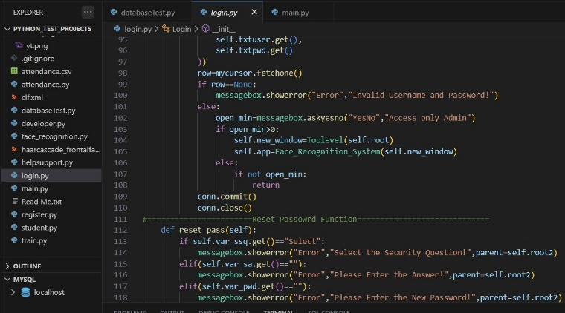authored.

Fig.1 Visual Studio code(software).

In this course we will be exploring installation, initialintion, and basic use ofthe IDE forthc purpose of writing VB Net.

1. **Fast & Smart Code Editinng**

Visual Studio irulents lines, malehes words and brackets, and highlights source code syntactically and semanticallyu Il lets you easily refractor code, with a range of handy and powerlill tools, while it also provides code templates, coding tips, and code generators.

1. **Easy Eflicient Project Management**

Keeping a clear over-vie'.v of large applications, with maximum numbers of folders and files, and maximum of lines ofcode, is a daunting task. Visual Studio provides different views of your data, from multiple project helpful for seeting up your applications and manage efficiently, letting you drill down into your data quickly and easily, while giving you versioning tools via Subversion. Mercurial, and integration out of box.

When new developers join your project, they can understand the structure of your application because your code is well-organized.

1. **MY SQL Database:**

MS'SQL is a Relational Database Management System (RDBMS).

*RDBMS* means R-DB- Management System.

R stands for Relational.

DB stands for Database, a repository for the information storage.

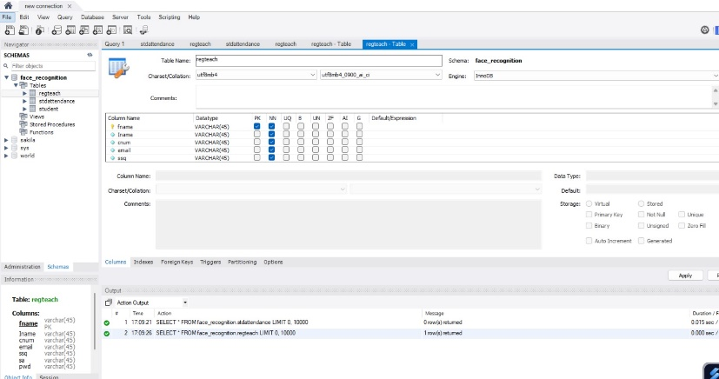R stands for Relational, indicates a particular kind of DBMS that is good at relating information stored in one table to infornntion stored in another table by looking for elements common to each of them. Relational DBMS has advantage of efficient storage, and retrieval mechanisms for data, and uses normalization proecSS during design of RDBMS.

Fig.2 My SQL Server

* **Features ofMySq1**

1. **Speed:**

The speed at which a server side program runs depends primarily on the server hardware. Given that server hardware is optimal, MySQL runs very fast. It Supports clustered servers ror demanding applications and Ease of use. MySQL is a high-performance, relatively simple dhtabase system.MySQL has typically been configured, monitered and managed the command line. However, several MySQL graphical interfaces are available as described below:

***MySQL Administrator*** :

This tool makes it possible for administrators to up, evaluate. and tune their MySQL database server. This is intended as a replacement for in MySQL admin.

It Provides database developers and operators with a graphical database oper interface.Configuration Administrators can choose from a predefined list Of optimal settings, or create their own.

1. **Cost:**

MySQL is available free of cost. MySQL is a "Open Source" database, MySQL is oft-AMP (Linux. Apache, MySQL„ PHP Perl Python) environment. a fast growing open enterprise software stack, More and more companies are using as an alternative to expensive proprietary software stacks at lower cost,reliability and documentation.

1. **Query Language Support:**

MySQL understands Standards based SQL (Structured Query Language)

1. **Capability**:

Many clients can connect to the server at the same time. Clients can use mulltiple database simultaneously. You early access MySQL using several interfaces such as command-line clients, Web browsers.

1. **Connectivity and security:**

MySQL is fully networked and database can be accessed from anywhere on the Internet, so you can share your data with anyone. The connectivity could be achieved with Windows programs by using ODBC By using the ODBC to MySQl Connectivity. any ODBC-aware application (for example, Microsoft report writers, Visual Basic) can connect to MySQL Portability.

1. 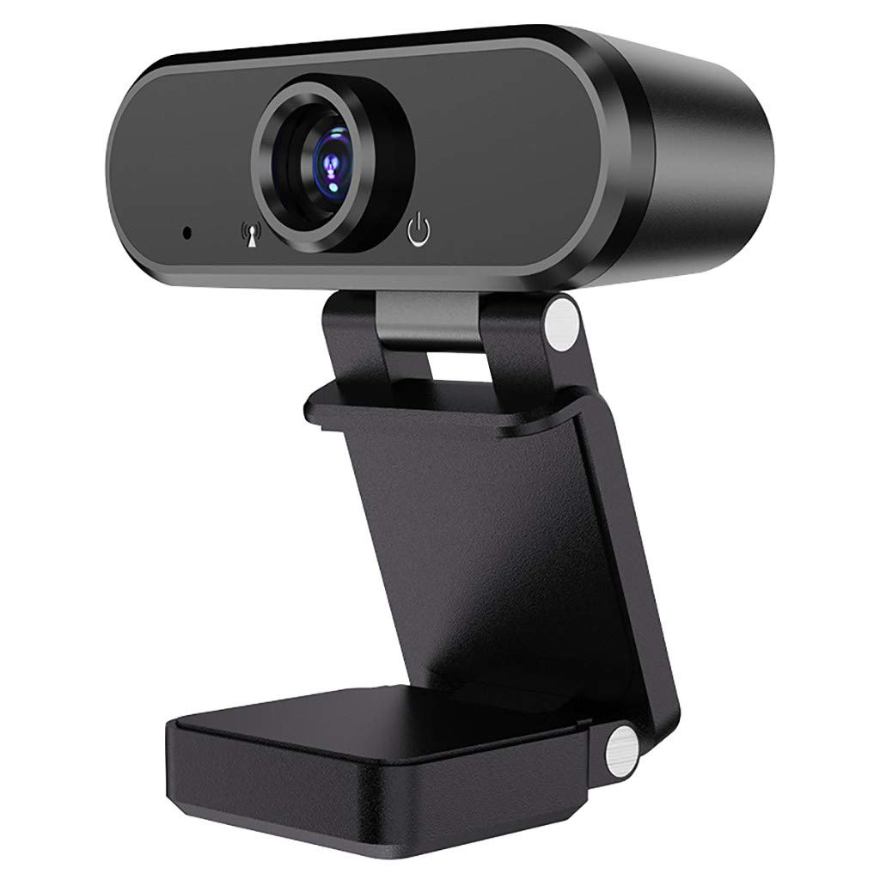**Webcam Camera:**

Fig. 3 Webcam Camera

Webcam is being used in this project to capture the images through it get clear clarity image with good quality pixels that makes easy to identify images recognite it more convieniently.

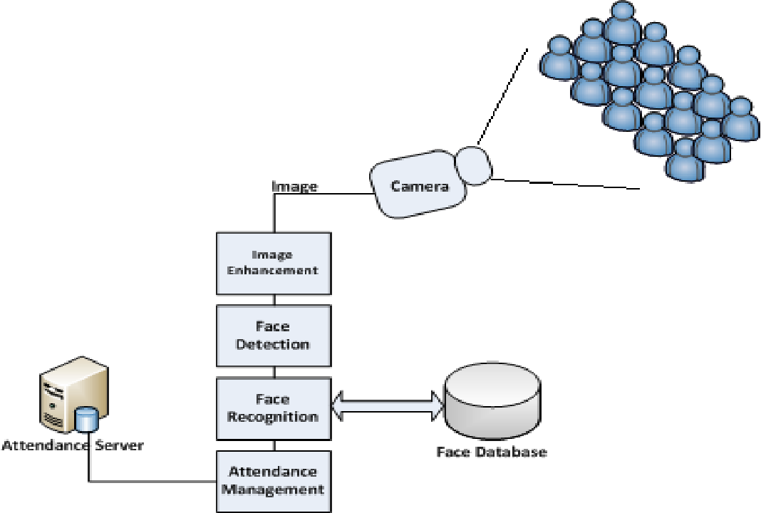4.2 Design of Project:-

Fig.4 Basic Design of Project.

**Input Design:-**

Input design is part of overall system design that requires special attention designing input data is to make the data entered easy and free from errors. The input forms are designed using the controls available in NET framework.

Input design is the process of converting the user originated inputs to computer based format a system user interacting through a workstation must be able to tell the system Whether to accept the input to produce reports. The collection of input data is considered io bc nwsi expensive part of the system design. Since the input bas to be planned in such a manner so as to get relevant information. extreme care is taken obtain pertinent information.

This project first will entered to the input of allocation farms it will be created on student details form and subject entry form. time table form will helps to calculate subject wise attendance system.

**Output Design:-**

Output design in this application "Automatic Student Attendance management system" generally refers to the results and information that arc generated by the system for many end-users; output is the main reason Tor developing the system and the basis on which they evaluate the usefulness orthe application.The output is designed in such a way that it is attractive, convenient and informative. Forms are designed with various features, which nuke console output more pleasuring.

As the outputs are the most important sources of information to the users; better design should improve the system's relationships us and also will help in decision making, Form design elaborates the way output is presented and the layout available for capturing information.One of the important factors of the system the output it produces. This system refers to the results and information generated, Basieally the output a eompuler system is used to communicate the result of processing to the user.

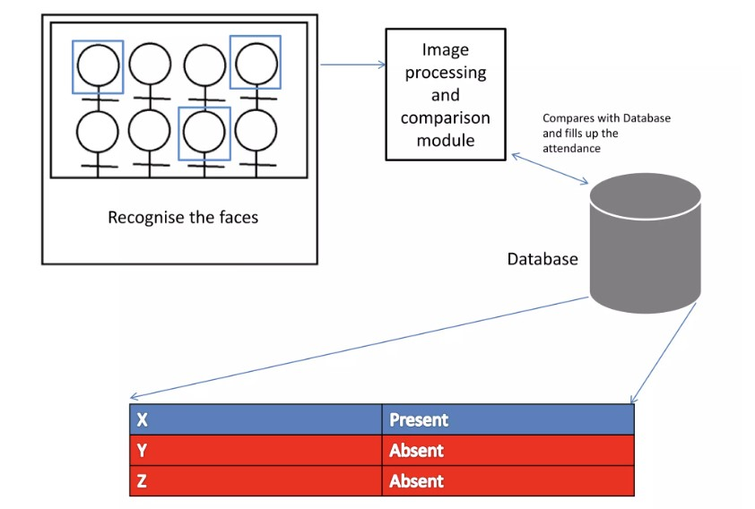 Attendance nunagement system to show the report subject wise attendance maintaining by staffs, Takeo as a whole repott Obtains on a administrator privileges only.

Fig.5 System Process.

* The Proposed system are divided into Five modules such as:
* Input image/Image Capture
* Face Detection
* Pre-Processing
* Data Development
* Post- Processing

**Input Image**

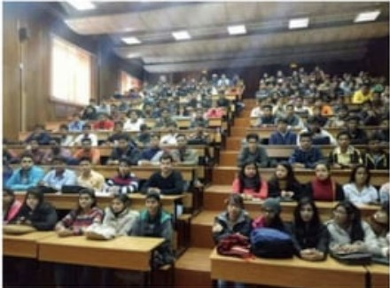 Although our own database should be used to design real time face recognition student attendance system, the databases that are provided by the previous researchers are also used to design the system more effectively, efficiently and for evaluation purposes.face database is used as both training set and testing set to evaluate the performance. face database contains one hundred and sixty-five grayscale images of fifteen individuals. There are eleven images per individual: each image orthe individual is in different condition. The conditions included center-light, with glasses, happy, left-light, without glasses, normal right-light, sad, sleepy, surprised and wink. These different variatlons provided by the database is able to ensure the system to be operated consistently in variety of situations and conditions.

Fig.6 Capturing Images for processing

Limitations of the image

The input image for the proposed approach has to be frontal, upright and only a single face. Although the system is designed to be able to recognize the student with glasses and without glasses, student should provide both facial images with and without glasses to be trained to increase the accuracy to be recognized without glasses, The training unage and testing Image should be captured by using the same device to avoid quality difference. The students have to register in order to be recognized. The enrolment can be done on the spot through the userfriendly interface.

**Face Detection:**

Face detection is a process oflocating a face inside an image frame, regardless of the identity ofthat face. Before recognizing a face. it is first essential to detect and extract the faces form the original pictures. Face Detection target on finding the faces (area and size) in an image and probably extract them to be used by the face recognition algorithm, In recent years, many methods are proposed redetecting the face.

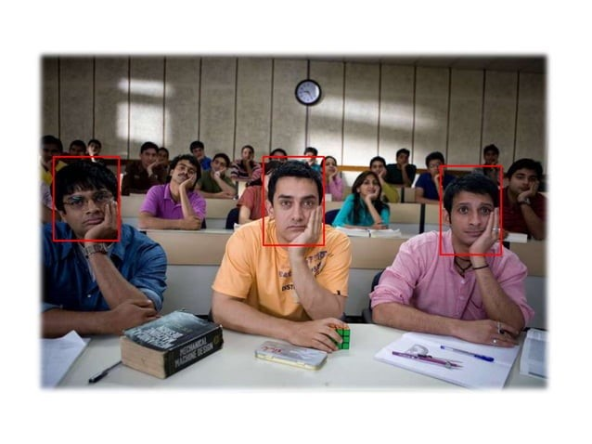Fig. 7 Face Detection of Students

In face detection methods, those Who are depending on training sets to capture the huge unevenness in facial features have enticed much attention and given the best results. Generally, these methods scan the input picture at all potential area and scales then as the sub windows either as non-face or face. Viola and Jones presented an effective detection technique using "Ai Feactures and Adu Boostasa’s quick training algorithm, For recognizing a face, the algorithms compare only faces. Any other Clement in the picture that is not part Of a face detection and recognition.

There are several existing algorithms for detecting mces- Prior to year 2000 there were rmny techniques for face detection, however they were mostly unreliabkf Slow and require manual inputs. In 2001 Viola and Jones invented the Haar-based-cascade a Classifier that revolutionize the face detection method, It can detect objects in real time with an accuracy of 95%. It works not only för frontal faces but it can detect faces from side view as well.

**Face Preprocessing:**

Testing set and training set images are captured using a camera. There are unwanted noise and uneven lighting exists in the images. Therefore, several pre-processing Steps are necessary before proceeding to feature extraction.Pre-processing steps that would be carried out include scaling of median filtering, conversion of colour images to gray scale and adaptive histogram equalization.

Any of the previous methods can be used for extracting faces from input pictures. The next step is to pre-process these faces in order to make the training phase easier and improve the probability to recognize a personcorrectly. The training data will be standardized. Notall the pictures have the same zoom on the filce and have maybe not all the same size. Most of the algorithms for facial recognition require the same size for the entire training set. Preprocessing includes different modifications. First of all, the faces need to be centered in the picture in the same way. The location Ofthe two eyes and the nose is Often used as a landmark for centering faces, The aim is to have the eyes at the same level and the nose at the same position for all images, To apply these modifications, the coordinates of the landmarks are needed.

After detecting a face the frame, we can now process the face inside the green rectangle, Face recognition is susceptible to changes in lighting conditions, face orientation, face expression, so it is paramount to diminish these differences as much as possible.

Processing images can be computationally expensive in a PC Of laptop, similarly in mobile devices. It requires higher processing power. Therefore, minimalizing the image processing in the mobile device is a must to achieve real-time face recognition system.

**Database development:**

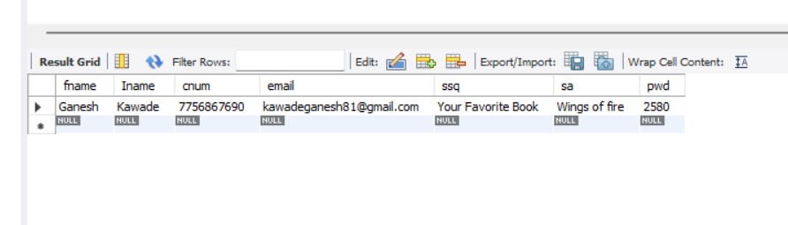 In this Biometric based system collection of every individual is required. This database development phase conststs of image capture orevery individual student and extracting the Bio-metric feature for every individual, in our proposed system it is face, and after it is enhanced using pre-processing techniques and to be stored in the database.

Fig.8 Database Creation

**Face Recognition/ Post Processing:**

Here the detected cropped faces are compared with the trained images from the database using correlation- if any orthe cropped image recognized then that Id would be marked present in the attendance data sheet.

Face recognition is executed using the face recognition library. step one of constructing a face recognition system is to detect the faces that is provided as an input, it is in the form of a static image format or a dynamic video source. those detected faces contained embeddings which are utilized by the system to apprehend the person or the faces detected. We extract these embeddings and it is learnt with the help of deep learning by the process of dataset training. Eventually, the faces were detected and recognised by the dataset in both static and dynamic formats.

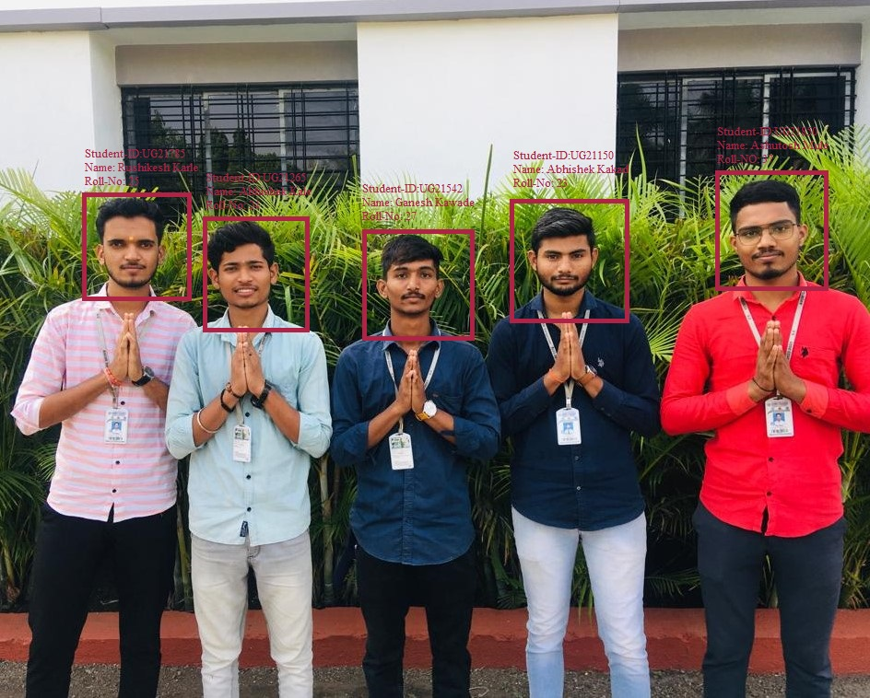Fig.9 Face Recognition of Students

4.3 Process Structure:-

* **Manage Registration and Login:**

1. **Register New Students:**

Description: Admin can register new

Input: Admin Details

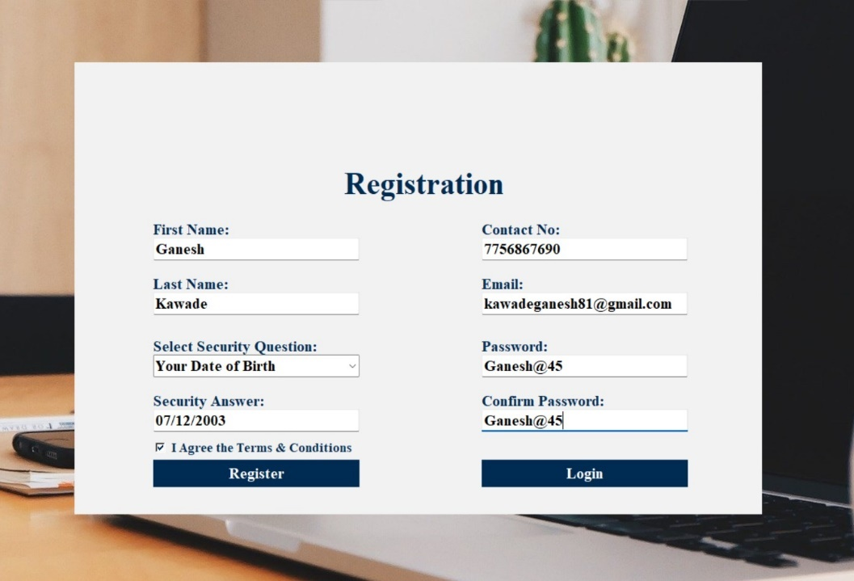Output: success message displaying the user has been created.

Fig. 10 Registration of Admin

1. 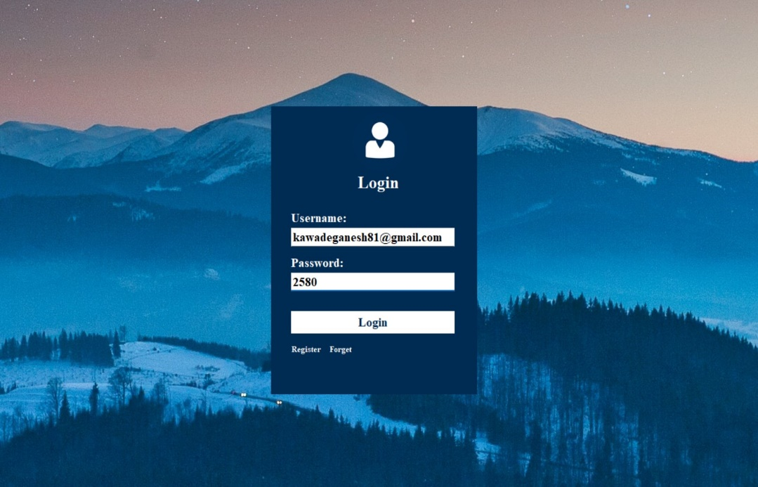**Log-In to the system:**

Fig. 11 Login to System.

Input: User credentials

Output: If the credentials are correct, user will be redirected to the dashboard of the system

Exception Flow: If the entered credentials are incorrect then user will be redirected to the login page again displaying an error message.

* **Manage Students Details:**

1. **Add the Students Details:**

Description:Admin can fill the data of students during registration.

Input: Students Details

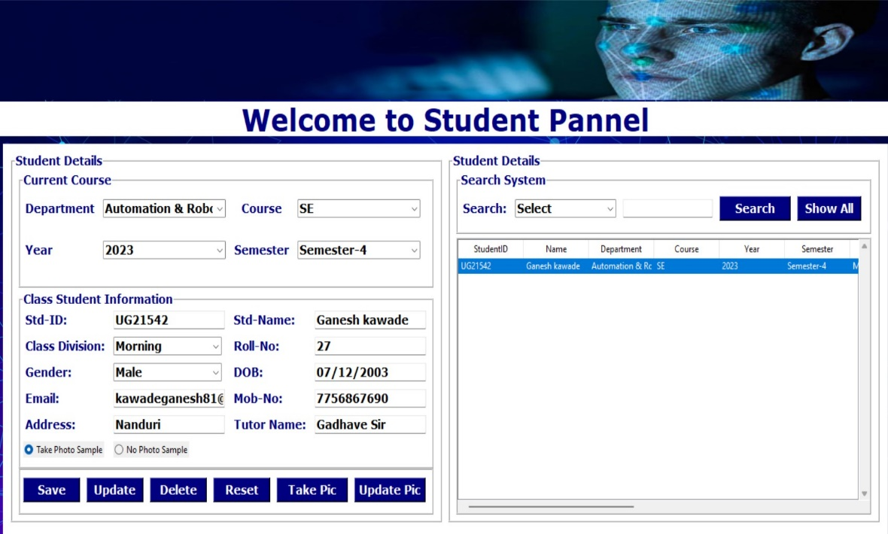Output:Student Details are Succesfully Stored.

Fig. 12 Registering Students Details

1. **Add photo of the Student:**

Description: Admin only can access this feature. Admin can add a photo of Students during the registration process.

Input: Details of Students

Output: Successfully message record has been added.

Process: System will process an image and will generate necessary system data to identify each Students uniquely.

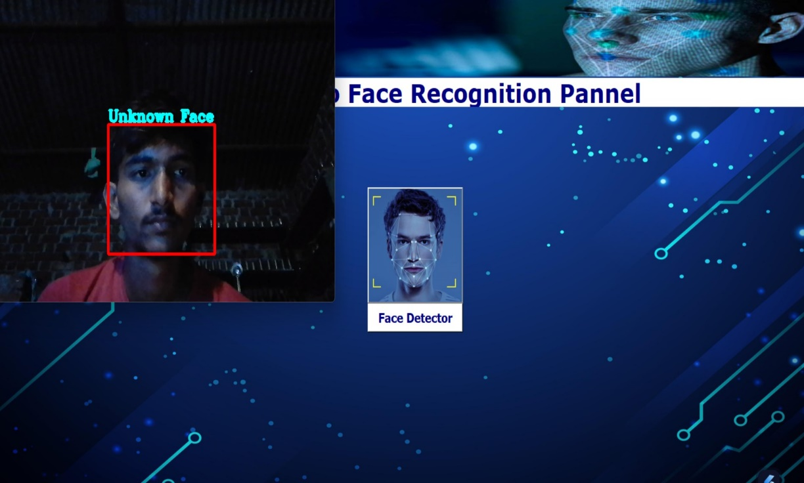Fig. 13 Adding Photos of Student

1. **Train the Data :**

Input: user selection

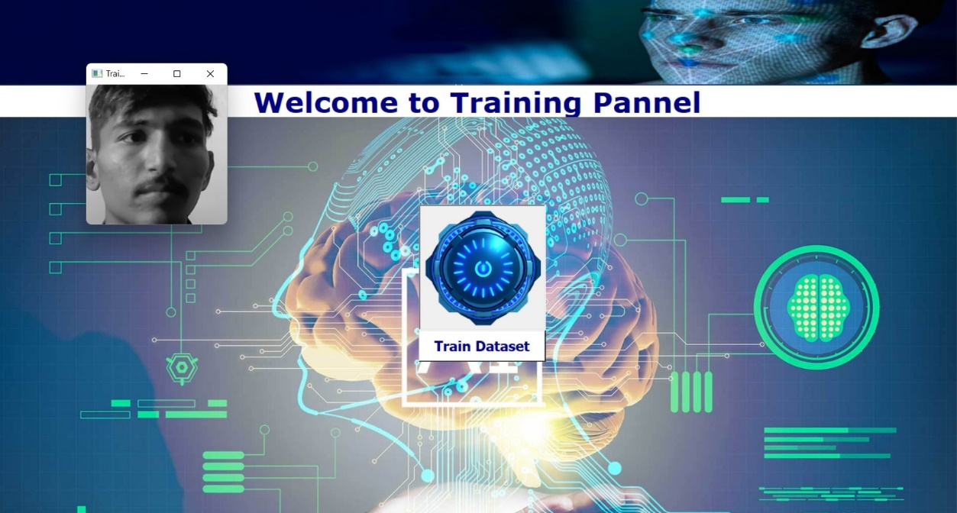Output: system will process all the available records of the employees and will generate necessary system data to identify each employee uniquely.

Fig. 14 Training the Dataset

* **Manage Attendance Details:**

1. **Mark Your Attendance-In:**

Input: User will scan his/her face using the external web camera.

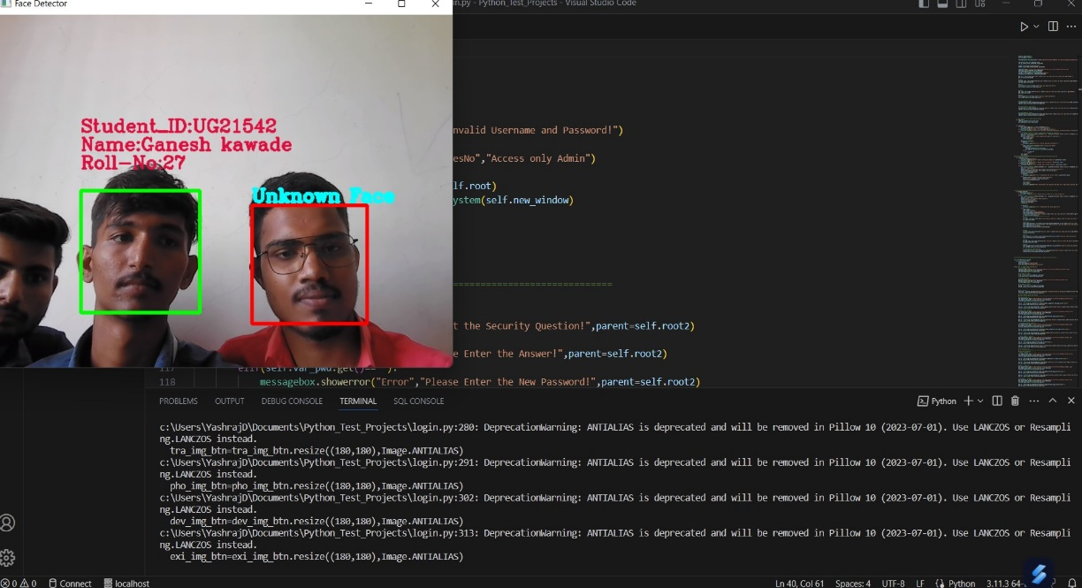Output: system will identify the user uniquely and will mark his/her in-time to the database. The same success message will be transmitted to the user.

Fig. 15 Marking the Attendance

1. 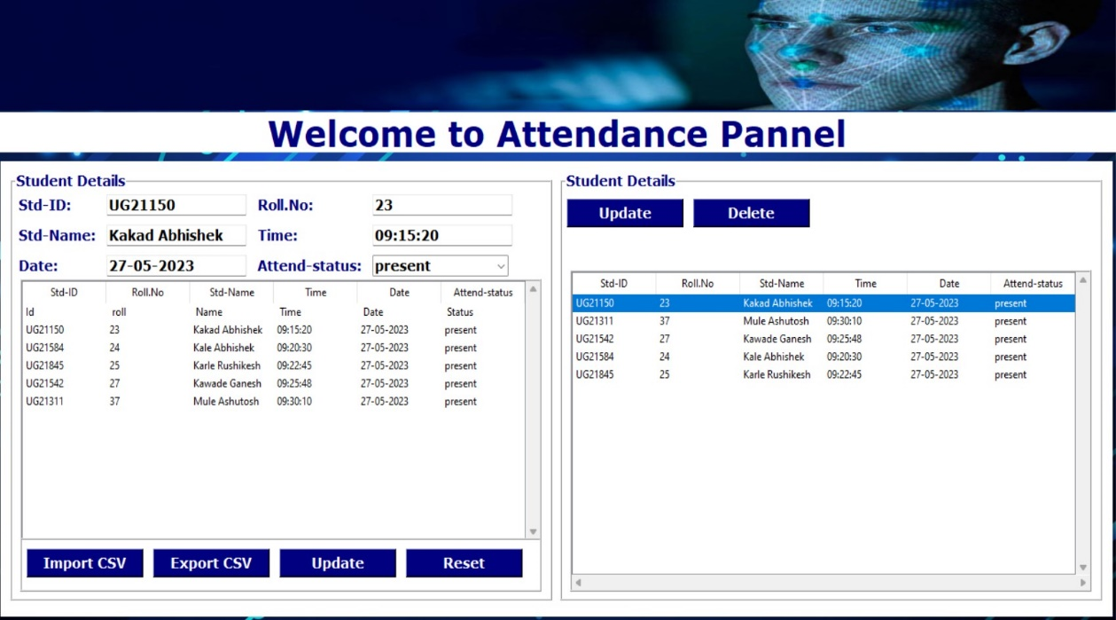**View My Attendance Report:**

Fig. 16 Viewing attendance Report

Description: Employee may often need to see his / her attendance record throughout the month or year. Using this feature one can see his / her attendance record till the date.

Input: User selection

Output: Statistical analytics of the particular employee who is currently logged into the system will be displayed.

1. **View Employee’s Attendance Report:**

Description: This feature is for admin. Admin can monitor the availability of each employee till the date. i.e., how many employees are present today out of total employees etc. can be monitored.

Input: user selection

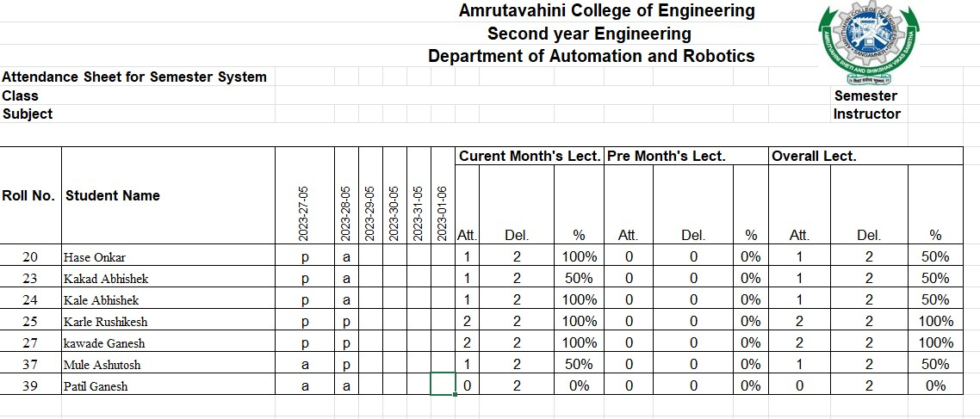Output: Attendance record of each employee including how many employees are present today out of total along with the availability graph.

Fig.17 Attendance Report

**Result and Discussion**

* **Advantages:-**

1. Great Time Saver.
2. Data will be digitally saved.
3. Real time status record.
4. Track Attendance at any time of student.
5. Increase Accuracy.
6. Being Efficient.

* **Limitations:-**

1. Attendance can be marked if the picture of an student is shown.
2. 100 images of each employee are taken for better accuracy. 100 Images per student in a larger university would consume a massive volume to store the images.
3. The training time for our classifier takes about 20 seconds for each person. Hence for a large number of students, it would take a very long time to train. Though training the classifier isn’t something that needs to be frequently done, but it would be better if a classifier taking lesser time while maintaining the accuracy can be built.
4. The current model is 99.38% Accurate.

* **Future Scope:-**

It can be easily implernented at any institute or organization.A method could be proposed to illustrate robustness against the variations that is, in near future we could build a system which would be robust and would work in undesirable conditions too. Here it is proposed for an institute to take the attendance of the students but in future it can be used to do the same work at entry as well as exit points- I am working to improve the face recognition effectiveness to build more efficient systems. In further work, authors intend to improve face recognition effectiveness by using the interaction among our system, the users and the administrators. On the Other hand, our system can be used in a completely new dimension of face recognition application, mobile based face recognition, which can be an aid for common people to know about any person being photographed by cell phone camera including proper authorization for accessing a centralized databaser.

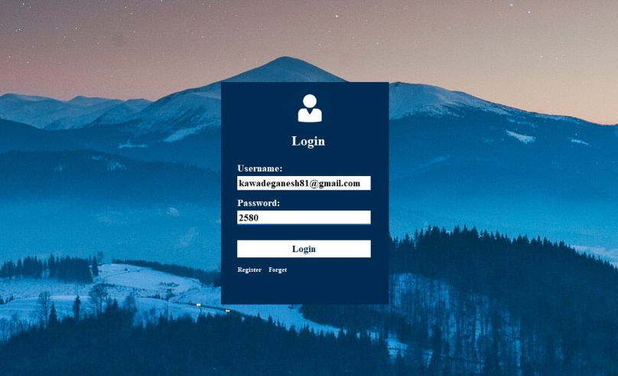**Photos**

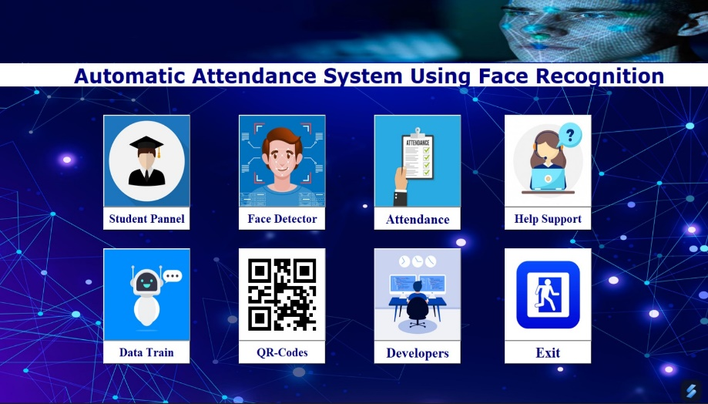

Fig .18 Login Page

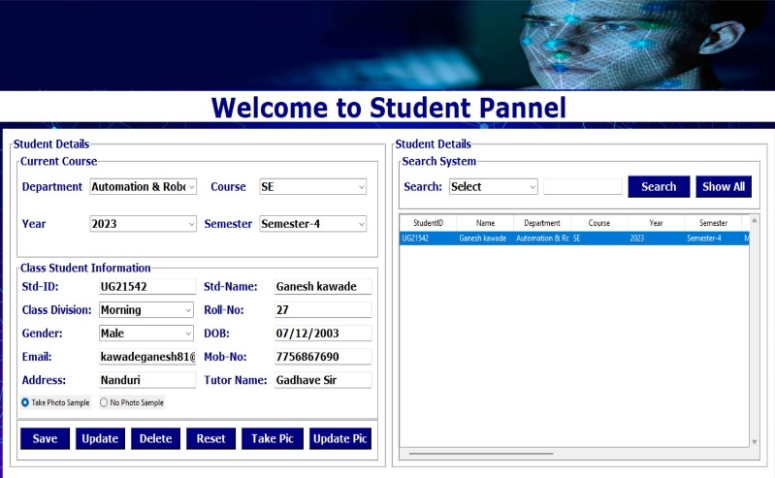 Fig.19 Main Page

Fig.20 Sudent panel

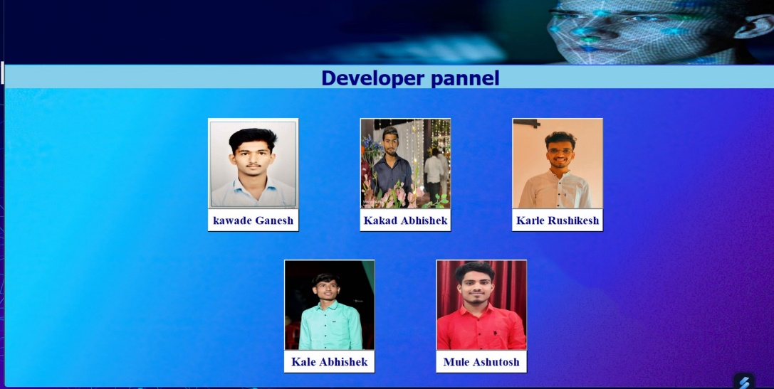Fig.21 Developer panel

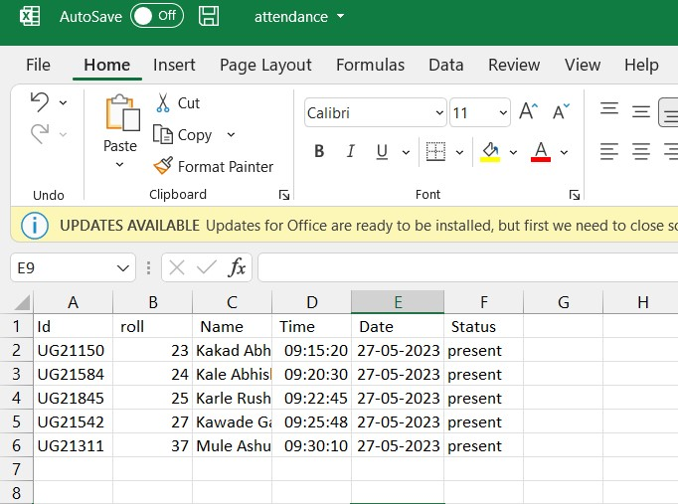

Fig. 22 Attendance Report

**Conclusion**

The Attendance Management System is developed using Visual Basic-BET fully meets the objectives Of the System which it has been developed. The system has reached a steady state where all bugs have been eliminatedw The system is operated at a high level ofemcieney and all the teachers and user associated with (the system understands its advantage. The system solves the problem, It was intended to solve as requirement specification.

As a conclusion for analysts, the extraction of facial feature eotild be challenging especially in different lighting. pre-processing Stage, Contrast Limited Adaptive Histogram Equalization (CLAHE) able to reduce the illumination effect' CLAE-IE perform better compared to histogram equalilittion in terms Ofcontrast improvement, Enhanced LBP with larger radius size specifically, radius size two, perform better compared to original LBP operator, with less affected by illumination and more consistent compared to other radius Slres.

order to maintain the attendance this system has been proposed. It replaces the manual system with an automated system which is fast, efficient, costand thne saving as replaces the stationary material and the paper work. Hence this system is expected to give desired results and in future could be implemented for logout' Also, the efficiency could be improved by integrating other techniques with it in near future, Jn this system we have implemented an attendance records to assist Faculty.

**Referances**

1. D. Gupta And S. Choubey, “Discrete Wavelet Transform For Image Processing,” International Journal Of Emerging Technology And Advanced Engineering, Vol. 4, Issue 3, March, 2015.
2. S. E. Handy, S. Lukas, And H. Margaretha, “Further Tests For Face Recognition Using Discrete Cosine Transform And Hidden Markov Model,” In Proc. International Conference On Electrical Engineering And Informatics (MICEEI), Makasar, 2012.
3. Radhika C.Damale, Prof.Bageshree.V.Pathak.“Face Recognition Based Attendance System Using Machine Learning Algorithms." Proceedings Of The Second International Conference On Intelligent Computing And Control Systems (ICICCS 2018) IEEE Xplore Compliant Part Number: CFP18K74-ART; ISBN:978-1-5386- 2842-3. Ieee 2018.
4. S. Kadry And K. Smaili, “A Design And Implementation Of A Wireless Iris Recognition Attendance Management System”, Information Technology And Control, Vol. 36, No. 3, Pp. 323–329, 2007
5. B. Bhanu, X. Tan, “Learned Templates For Feature Extraction In Fingerprint Images”, Proceedings Of The IEEE Conference On Computer Vision And Pettern Recognition, Vol.2, 2001, Pp.591-596.
6. T. Lim, S. Sim, And M. Mansor, “Rfid Based Attendance System”, In Industrial Electronics & Applications, 2009. Isiea 2009. IEEE Symposium On, Vol. 2. IEEE, 2009.